

Name | Muhammad Ruslan Babar
Student ID | 24079307
Course | Machine Learning and Neural Networks
Date | 11 December 2025
Instructor | Peter Scicluna

Table of Contents
Abstract 3
1. Introduction 4
2. Dataset: MNIST 4
3. Method: Model Designs and Training Setup 5
Models Compared 5
3.1 Architecture 6
3.2 Code Snippets 6
Loading and Preparing Datasets 6
Visual Example Of the Dataset 7
Building the MLP using the Keras Functional API 7
Compiling the Model 8
Training the Model 8
4. Results 9
4.1 Test Accuracy 9
Interpretation: 9
4.2 Training Time 9
Interpretation: 10
4.3 Validation Accuracy Curves 10
4.4 Validation Loss Curves 10
4.5 Confusion Matrices 11
5. Why These Results Happen 13
5.1 MNIST Is Too Simple for Deep MLPs 13
5.2 Vanishing Gradient Problem 13
5.3 Many More Parameters = Harder to Optimise 13
5.4 Simple Models Generalise Better 13
6. Ethical Discussion 13
6.1 Bias 13
6.2 Accessibility 14
6.3 Environmental Cost 14
7. Conclusion 14
8. References 14

Table of Figures

Figure 1 Model architecture for the 2-hidden-layer Multilayer Perceptron. The network consists of a 784-dimensional input, followed by Dense(128, ReLU) and Dense(64, ReLU) hidden layers, and a final Dense(10, Softmax) output layer. 5
Figure 2 Loading and preparing dataset 5
Figure 3 Visual Example of dataset 6
Figure 4 MLP Model 6
Figure 5 Model Compilation 7
Figure 6 Training Model 7
Figure 7 Test accuracy for all three MLP depths. The 1-layer model performed best (91.1%), while the 3-layer model performed worst (30.5%). 8
Figure 8 Training time increases with depth. The 3-layer model was the slowest to train (137.8 seconds). 9
Figure 9 Validation accuracy across 20 epochs. The 1-layer model remained stable, while the 3-layer model collapsed early and never recovered. 9
Figure 10 Validation loss across 20 epochs. The 3-layer model showed extreme instability with exploding loss values. 10
Figure 11 Confusion Matrix for MLP with 1 hidden layer 10
Figure 12 Confusion Matrix for MLP with 2 hidden layer 11
Figure 13 Confusion Matrix for MLP with 3 hidden layer 11

Abstract
This tutorial explores how the depth of a Multilayer Perceptron (MLP) affects its performance on the MNIST handwritten digits dataset. Three models were compared: one with a single hidden layer, one with two hidden layers, and one with three hidden layers. Each network was trained using the same optimiser, loss function, and training settings to ensure a fair comparison. The results show that the one-hidden-layer MLP achieved the highest accuracy (91.1%), while deeper models performed worse, with the three-hidden-layer network failing to converge and reaching only 30.5% accuracy. Validation accuracy and loss curves further reveal that deeper networks experienced training instability, likely due to vanishing gradients and increased parameter complexity. Confusion matrices confirm that the shallow model generalised well, while the deeper models produced many incorrect predictions. These findings highlight that increasing depth does not always improve performance and that model complexity must match dataset difficulty. The tutorial demonstrates this behaviour through code examples, visualisations, and clear explanations to support learners in understanding how MLP depth influences learning outcomes.

How the Depth of a Multilayer Perceptron Affects Performance on the MNIST Dataset

1. Introduction
A Multilayer Perceptron (MLP) is one of the simplest types of neural networks. It is made of layers of neurons, where each neuron takes numbers in, multiplies them by weights, adds a bias, and then applies an activation function.
A single neuron can be written as:
y=f(Wx+b)
Where:
- x is the input vector
- W is the weight matrix
- b is the bias
- f is the activation function
An MLP becomes deeper when more hidden layers are added. Depth = number of layers the data passes through before reaching the output.
In this tutorial, we explore how adding more hidden layers changes the performance of an MLP on the MNIST handwritten digits dataset. [1]

We compare three models:
- MLP with 1 hidden layer
- MLP with 2 hidden layers
- MLP with 3 hidden layers
Our goal is to understand how depth affects:
- test accuracy
- training time
- learning behaviour
- validation loss curves
- validation accuracy curves
- model stability
- overfitting

2. Dataset: MNIST
MNIST is a simple and widely used dataset that contains:
- 70,000 images of handwritten digits (0–9)
- Each image is 28 × 28 pixels, greyscale.
- 60,000 images for training
- 10,000 images for testing
We flatten each image into a vector of length 784 (28×28) and scale pixel values to between 0 and 1.
MNIST is ideal for beginners because it is small, easy to understand, and trains quickly. [1]

3. Method: Model Designs and Training Setup
All three models were built using TensorFlow/Keras Functional API, which allows clear control of the architecture. [2]
Each model uses:
- ReLU activation in hidden layers
  - f(x) = max(0, x)
- Softmax activation in the output
  - ŷᵢ = e^(zᵢ) / Σ (from j=1 to 10) e^(zⱼ)
- Categorical cross-entropy loss
  - L = - Σ (from i=1 to 10) yᵢ * log(ŷᵢ)
- Adam optimiser
- 20 epochs
- Batch size 128
- 10% of training data used for validation.

Models Compared
- Model A — 1 Hidden Layer (Shallow Network)
[128]
- Model B — 2 Hidden Layers (Medium Depth)
[128, 64]
- Model C — 3 Hidden Layers (Deep Network)
[256, 128, 64]
Each model was trained on the same data, with the same optimiser and hyperparameters, so the comparison is fair.

3.1 Architecture
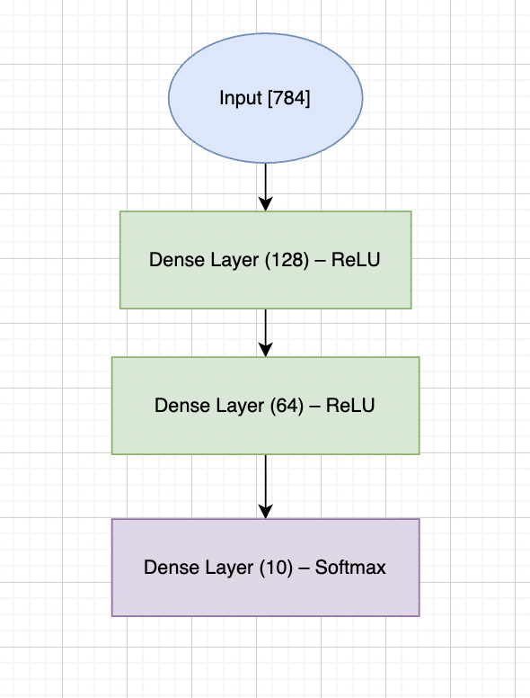
Figure 1 Model architecture for the 2-hidden-layer Multilayer Perceptron. The network consists of a 784-dimensional input, followed by Dense(128, ReLU) and Dense(64, ReLU) hidden layers, and a final Dense(10, Softmax) output layer.

3.2 Code Snippets
The following short code snippets show how the MLP models were built, compiled, and trained using the Keras Functional API. The full code is provided in the accompanying Jupyter notebook. [3]

Loading and Preparing Datasets
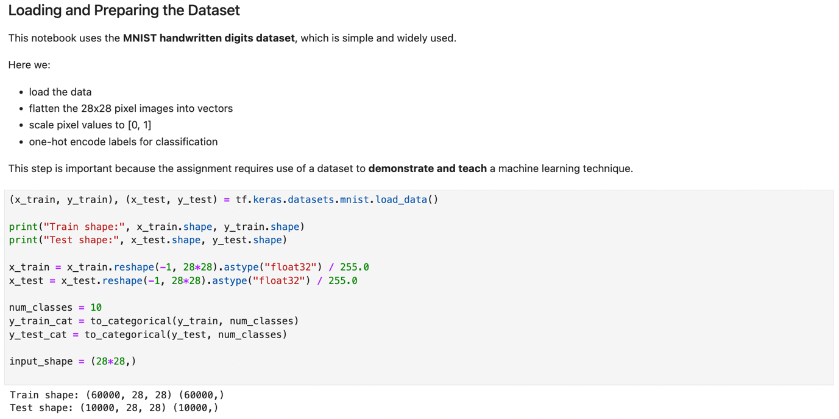
Figure 2 Loading and preparing dataset

Visual Example Of the Dataset
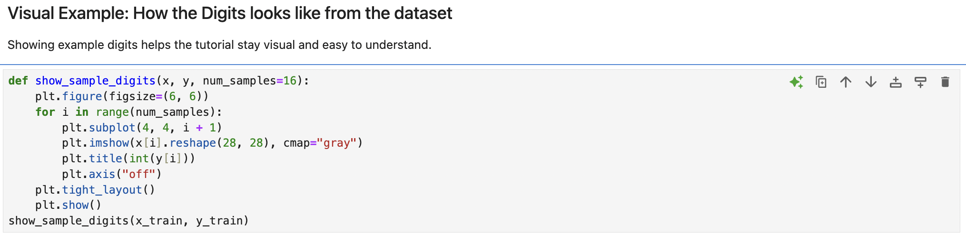
Figure 3 Visual Example of dataset
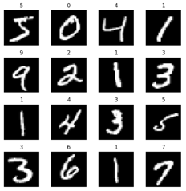

Building the MLP using the Keras Functional API
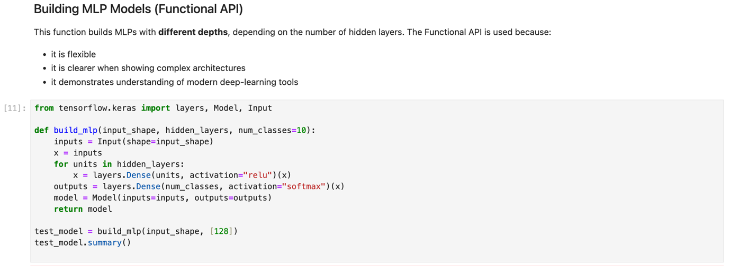
Figure 4 MLP Model

Compiling the Model
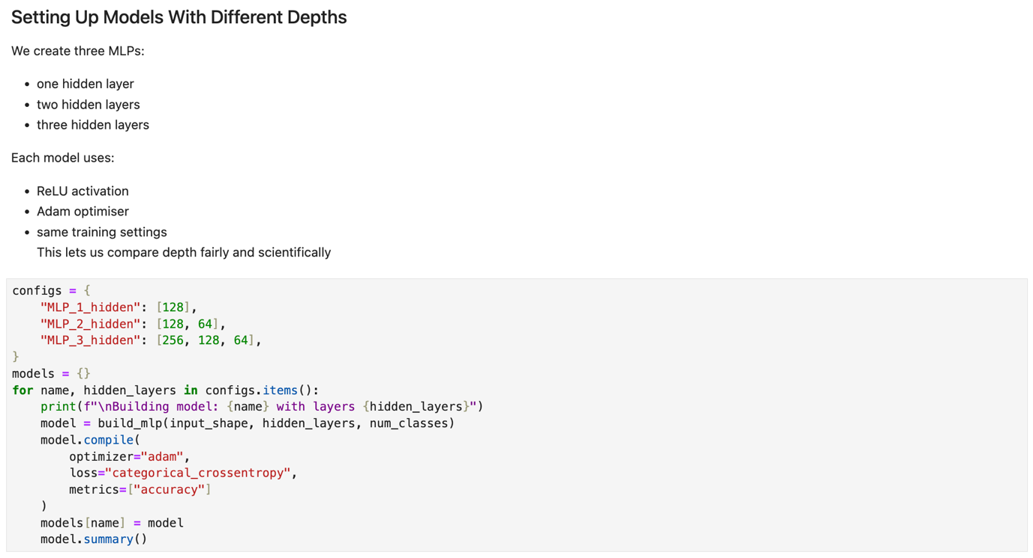
Figure 5 Model Compilation
The model is trained using the Adam optimiser and cross-entropy loss.

Training the Model
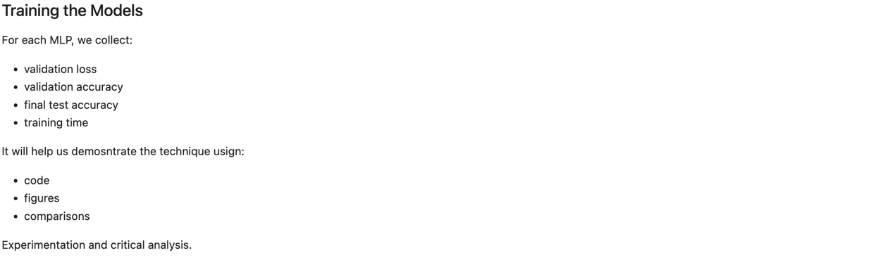
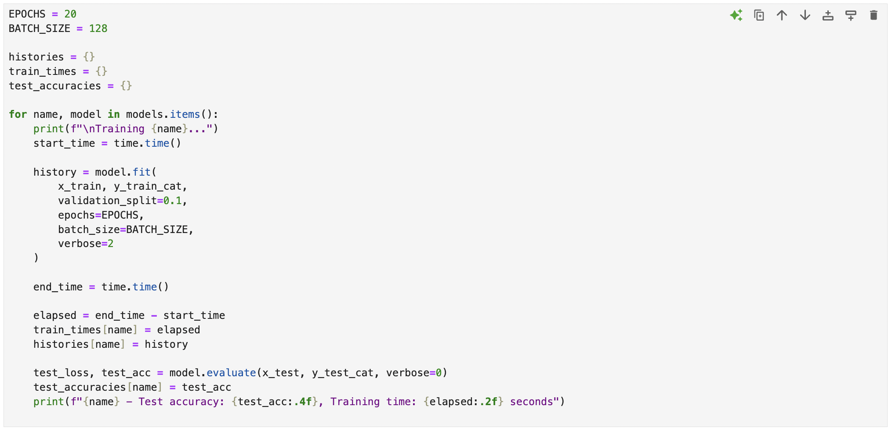
Figure 6 Training Model
The model is trained for 20 epochs with 10% of the training data used for validation.
These results generate the accuracy and loss curves shown in Section 4.

4. Results
Below is a summary in figures and numbers for your real experiment outputs.

4.1 Test Accuracy
The test accuracy values from your experiment were:

Model | Test Accuracy
MLP (1 hidden layer) | 0.911
MLP (2 hidden layers) | 0.744
MLP (3 hidden layers) | 0.305

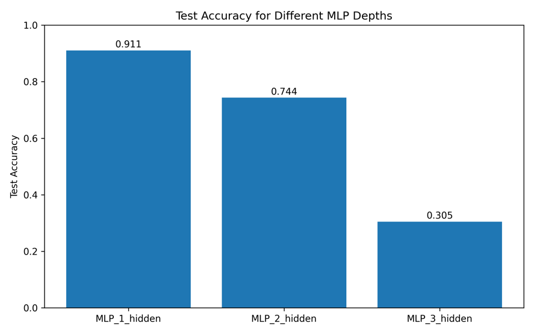
Figure 7 Test accuracy for all three MLP depths. The 1-layer model performed best (91.1%), while the 3-layer model performed worst (30.5%).

Interpretation:
- The 1-layer model performed best, reaching 91.1% accuracy.
- The accuracy dropped to 74.4% with 2 hidden layers.
- The 3-layer model performed poorly, with only 30.5% accuracy.
This shows that deeper models did not help for MNIST. In fact, they made performance worse.

4.2 Training Time
Your recorded training times were:

Model | Training Time
MLP (1 hidden layer) | 101.1 seconds
MLP (2 hidden layers) | 117.5 seconds
MLP (3 hidden layers) | 137.8 seconds

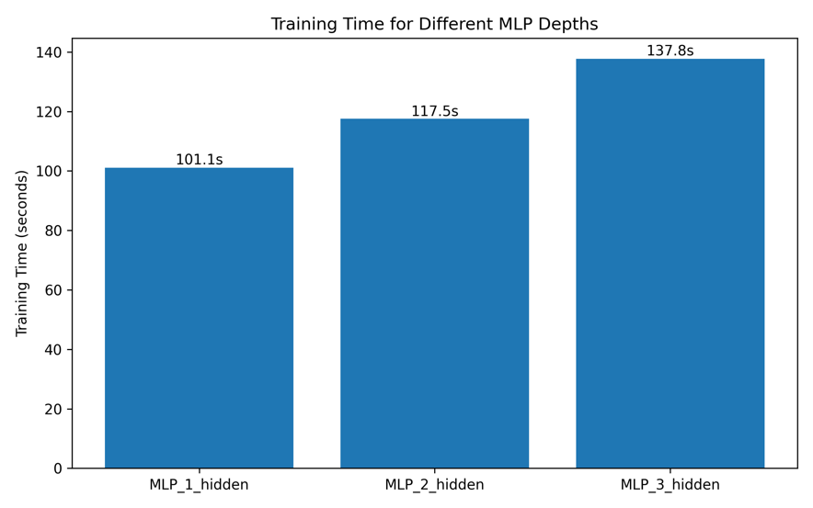
Figure 8 Training time increases with depth. The 3-layer model was the slowest to train (137.8 seconds).

Interpretation:
- More layers → more weights → slower training
- The deepest model was 36% slower than the shallowest.
- Yet, it produced much worse accuracy.

This shows a bad trade-off: slower and less accurate.

4.3 Validation Accuracy Curves
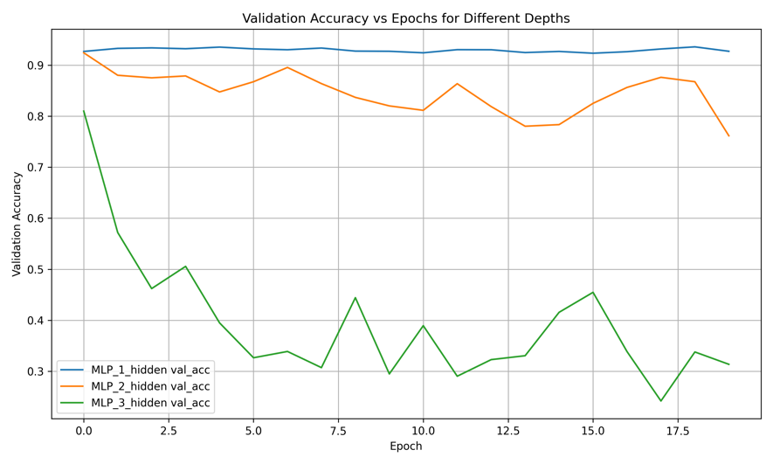
Figure 9 Validation accuracy across 20 epochs. The 1-layer model remained stable, while the 3-layer model collapsed early and never recovered.
From your graph:
- 1-layer model stayed high and stable around ~0.92
- 2-layer model fluctuated between ~0.82 and 0.88
- 3-layer model dropped rapidly below 0.40 and stayed unstable
This shows the deeper model could not learn stable features. [4]

4.4 Validation Loss Curves
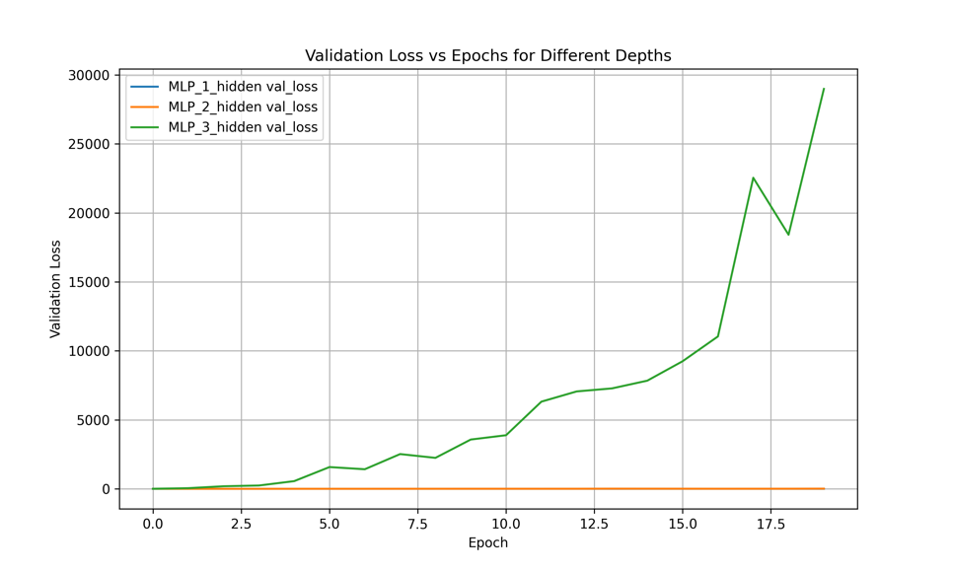
Figure 10 Validation loss across 20 epochs. The 3-layer model showed extreme instability with exploding loss values.
Your validation loss graph showed:
- 1-layer model: low, smooth loss
- 2-layer model: slightly higher but still stable
- 3-layer model: loss exploded above 30,000 and kept increasing

This is a strong sign of:
- unstable optimisation
- vanishing/exploding gradients
- the model failing to converge.
The deeper network was not suitable for MNIST. [5]

4.5 Confusion Matrices
To understand how each MLP model behaved on individual digit classes, confusion matrices were generated. These matrices show how often each true digit (0–9) was correctly or incorrectly predicted.
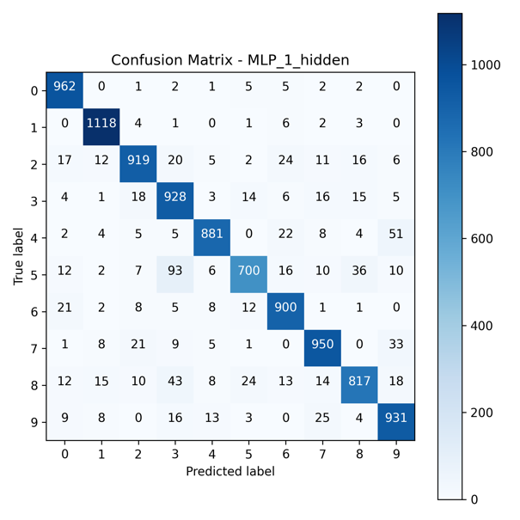
Figure 11 Confusion Matrix for MLP with 1 hidden layer
The 1-hidden-layer model showed a strong diagonal pattern, meaning most digits were classified correctly. Small errors occurred mainly between visually similar digits such as 4 and 9 or 3 and 5. This indicates good generalisation.
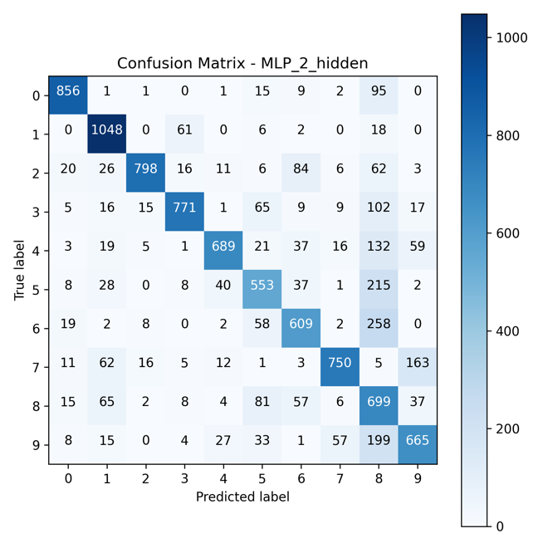
Figure 12 Confusion Matrix for MLP with 2 hidden layer
The 2-hidden-layer model showed more off-diagonal values. It made more mistakes on digits such as 2, 7, 8, and 9. This matches its lower validation accuracy and suggests that the extra depth did not improve the model’s ability to learn stable representations.
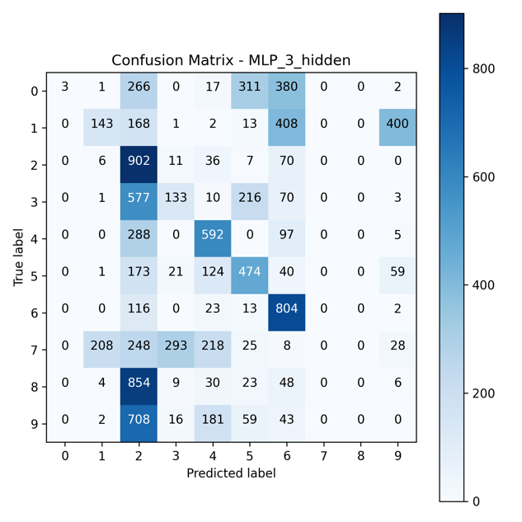
Figure 13 Confusion Matrix for MLP with 3 hidden layer

The 3-hidden-layer model showed a very weak diagonal and many incorrect predictions. This agrees with its poor accuracy (30.5%) and exploding validation loss. The confusion matrix confirms that the deepest network did not converge properly and failed to learn useful MNIST features.

Overall, the confusion matrices provide strong visual evidence that adding more hidden layers made the model less stable and less accurate.

5. Why These Results Happen

W_new = W_old − η * ∂L/∂W

5.1 MNIST Is Too Simple for Deep MLPs
MNIST digits are extremely low resolution (28×28). A deep network is unnecessary. A shallow model can learn all patterns easily. [5] [4]

5.2 Vanishing Gradient Problem
In deep fully connected networks:
- gradients get smaller as they move backward.
- early layers learn very slowly.
- deep layers cannot update properly.
This can cause failure to learn.

5.3 Many More Parameters = Harder to Optimise
Deep MLPs have huge weight matrices. This can lead to:
- divergence
- noisy updates
- exploding loss
- overfitting

5.4 Simple Models Generalise Better
Your results show that:
- shallow models learned clear patterns.
- deeper models memorised noise or failed to learn altogether.

This matches real machine learning advice:
“Start simple. Only add depth when the problem is complex.”

6. Ethical Discussion
Even though MNIST is simple, it raises ethical points:

6.1 Bias
Handwriting varies across:
- age
- culture
- gender
- education
Models trained only on MNIST may not perform well on real handwriting.

6.2 Accessibility
When presenting machine learning results:
- colour-blind friendly plots should be used.
- text descriptions should accompany images.
- clean labels improve readability.

6.3 Environmental Cost
Deeper networks took longer to train. More compute = more energy.
Shallow models are more environmentally friendly.

7. Conclusion
From this experiment, we can clearly conclude:
- The 1-hidden-layer MLP performed the best with 91.1% accuracy.
- Adding more hidden layers did not improve performance.
- The 3-layer model was unstable and achieved only 30.5% accuracy.
- Training time increased with depth, but accuracy decreased.
- MNIST is simple, so a shallow MLP is the best choice.

So, the Lesson is:
More layers do not always make a model better. Depth must match the complexity of the dataset.

8. References

[1] | Y. B. L. B. Y. &. H. P. (. LeCun, "• LeCun, Y., Bottou, L., Bengio, Y., & Haffner, P. (1998). Gradient-Based Learning Applied to Document Recognition.".
[2] | I. B. Y. &. C. A. Goodfellow.
[3] | I. B. Y. &. C. A. Goodfellow, "• Goodfellow, I., Bengio, Y., & Courville, A. Deep Learning.".
[4] | T. Documentation, "TensorFlow Documentation – https://www.tensorflow.org".
[5] | K. API, "Keras API – https://keras.io".
[6] | M. Dataset, "MNIST Dataset – http://yann.lecun.com/exdb/mnist/".

